You need to construct a binary tree from a string consisting of parenthesis and integers.

The whole input represents a binary tree. It contains an integer followed by zero, one or two pairs of parenthesis. The integer represents the root's value and a pair of parenthesis contains a child binary tree with the same structure.

You always start to construct the **left** child node of the parent first if it exists.

**Example 1:**

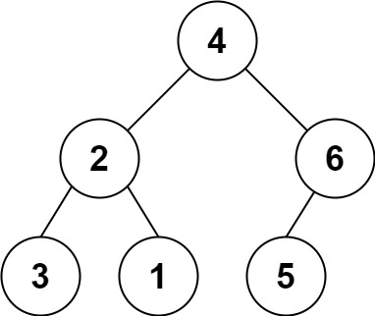

Input: s = "4(2(3)(1))(6(5))"  
Output: [4,2,6,3,1,5]

**Example 2:**

Input: s = "4(2(3)(1))(6(5)(7))"  
Output: [4,2,6,3,1,5,7]

**Example 3:**

Input: s = "-4(2(3)(1))(6(5)(7))"  
Output: [-4,2,6,3,1,5,7]

**Constraints:**

* 0 <= s.length <= 3 * 104
* s consists of digits, '(', ')', and '-' only.